**How to run the Online Library management System Django Python**

**1.** Download the zip file

**2.** Extract the file, copy library folder, and paste it on the desktop

**3.** Open MySQL Create a database olmspythondb then import the SQL File available in the SQL File Folder (For MySQL we used [XAMPP](https://phpgurukul.com/how-to-install-xampp/)server)

**4.** Open PyCharm and click on the terminal

**5.** Navigate the project folder using the cd command

cd project_path

**For ex:**cd C:\Users\ANUJ\OneDrive\Desktop\library\

**6.** Now Navigate to the olms folder

cd olms

**7.** Run the Project using the following command

python manage.py runserver

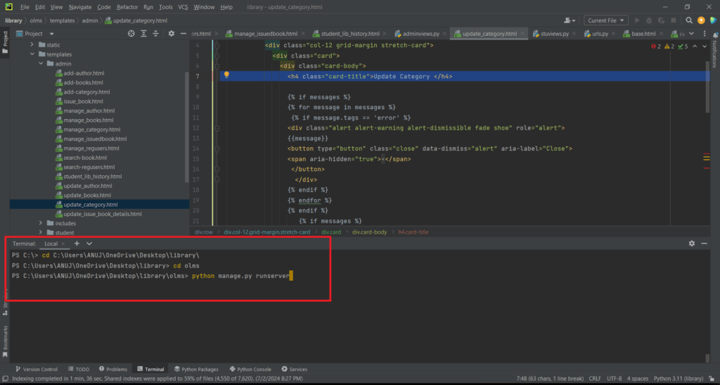

Now click the URL http://127.0.0.1:8000 and the Project will run

**Login Details**

**\*\*\*\*\*\*\*\*\*\*\*\*\*admin\*\*\*\*\*\*\*\*\*\*\*\***

**Username:**admin

**Password:** Test@123

**\*\*\*\*\*\*\*\*\*\*\*\*\*User/Student\*\*\*\*\*\*\*\*\*\*\*\*\*\***

**Username:**john12345

**Password:** Test@123 or Register a new Student